BREAKFAST CHATTER
Weekly Bulletin of Rotary Club of Kathmandu Mid-Town
District 3290 Volume No. 15/14 for #756 October 15 2004
www.rotarymidtown.org.np
OCTOBER IS VOCATIONAL SERVICE MONTH

SUNSHINE ANNOUNCEMENT FOR THE WEEKS OF 15 and 22 October 2004;
What week is this? Auspiciously the sky is finally clear. The mountains are shining. But per the statistics, no one was born, no one was married! Fortunately, in the following week there would be a party – IF there were a meeting. In advance - Happy Birthday to Monica (s/o Mahendra), Usha (s/o Govinda), Lekha and Luke!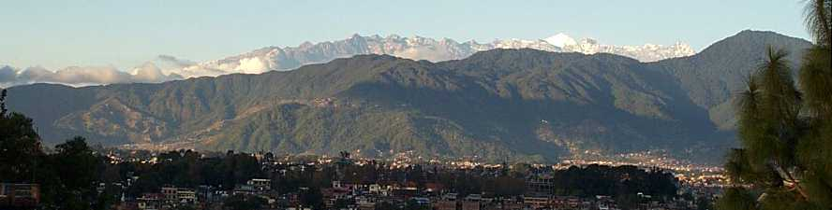
****************

MEETING ACTIVITIES:

DATE | ACTIVITY | SUBJECT
15 OCT | David Sowerwine | Building Bridges in Nepal
22 OCT | Dasain Holiday | Off- Everyone Work for Peace
29 OCT | Shyam Nepali | All about Sarangis (music included)
5 NOV | Biswajit Chakraborty | Topic to be Announced

****************
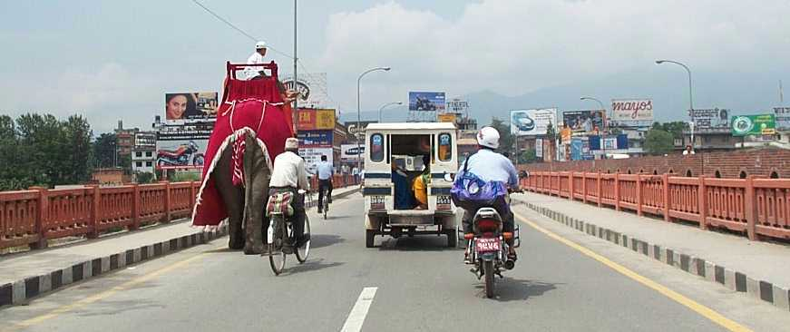
NEWS ……Our good wishes will follow Dr Robert and Giannina Scott on their journey home. Thanks for sharing your adventures and work in Nepal with us. As you head out of town, remember how the traffic was on a crowded day. Where else??…Thanks to all Rotarians who contributed generously to the relief fund for Nepal’s Muslims.
****************
THIS WEEK’S PRESENTATION BY YOURS TRULY, DAVID
This Friday I will share with you our adventures in building bridges in Nepal. During the past six years we have completed 27 WireBridges, linking tens of thousands of villagers with their schools, health posts, relatives… Both a symbol and a reality, they bring people together. A summary is attached.
**************** YIR…David

